TASK 5

Contact Information: Store name, phone number, email, and address for each contact.

Add Contact: Allow users to add new contacts with their details.

View Contact List: Display a list of all saved contacts with names and phone numbers.

Search Contact: Implement a search function to find contacts by name or phone number.

Update Contact: Enable users to update contact details.

Delete Contact: Provide an option to delete a contact.

User Interface: Design a user-friendly interface for easy interaction.

CODE:

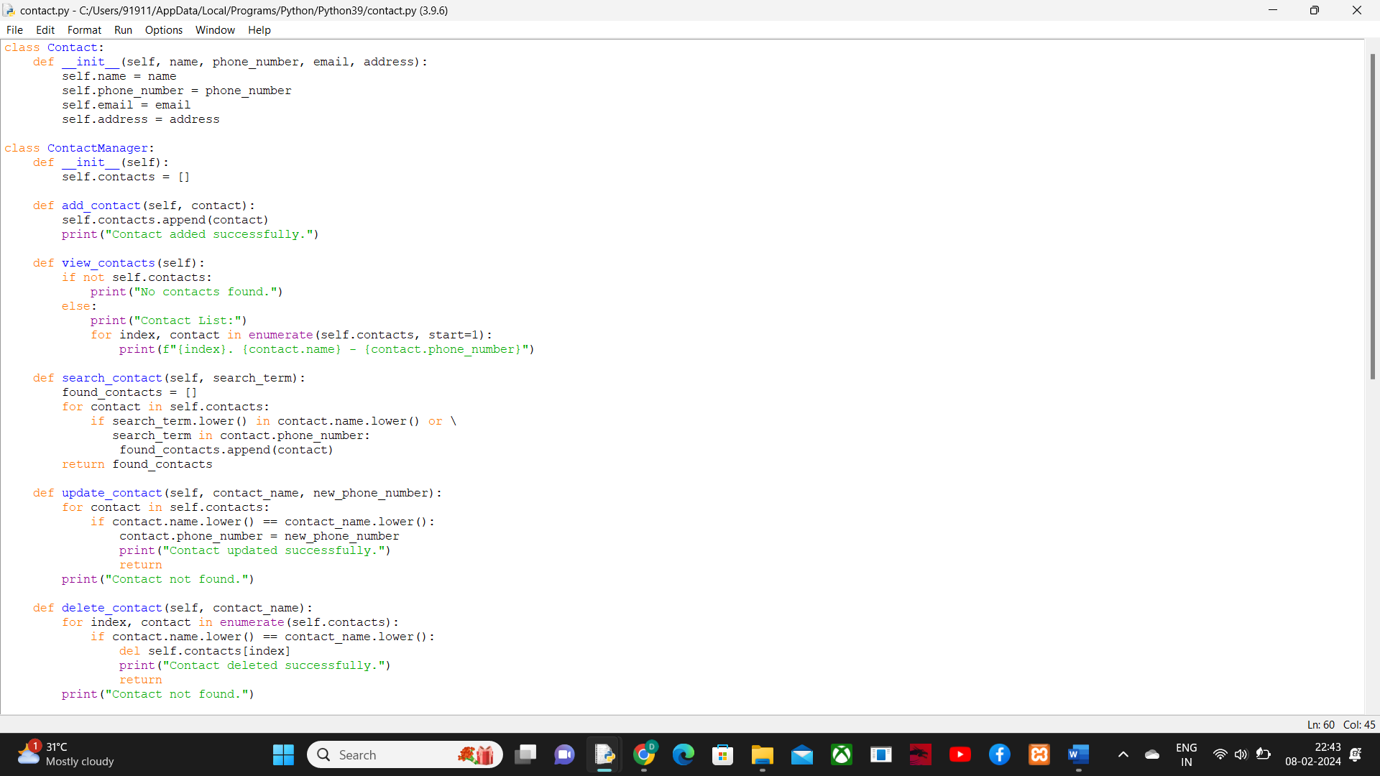

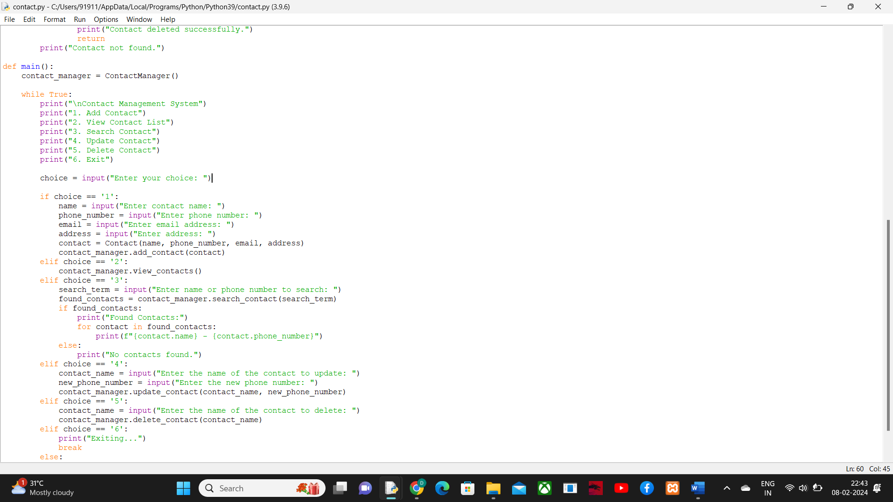

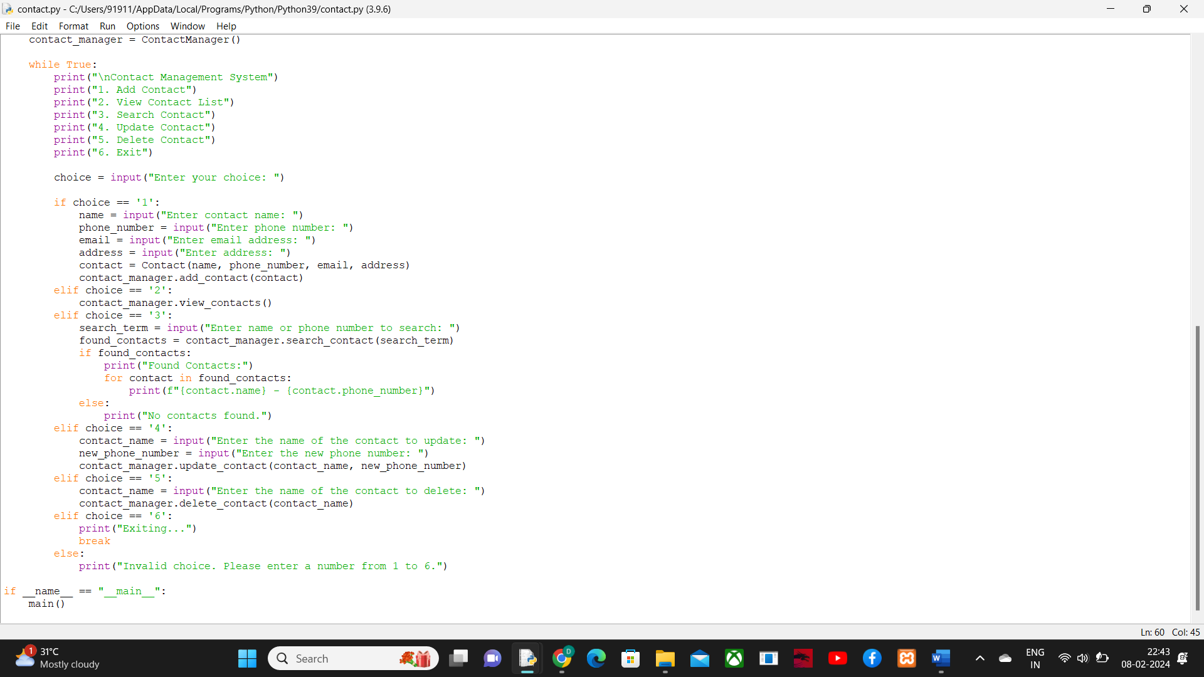

OUTPUT:

